**Project Design Phase-II**

**Data Flow Diagram & User Stories**

|  |  |
| --- | --- |
| Date | 27 June 2025 |
| Team ID | LTVIP2025TMID20380 |
| Project Name | HouseHunt: Finding your perfect rental home |
| Maximum Marks | 4 Marks |

**Data Flow Diagrams (DFD) – HouseHunt**

A Data Flow Diagram (DFD) is a visual representation of how data moves through the HouseHunt online rental platform. It outlines how data enters the system, how it is processed, where it is stored, and how it exits the system. The DFD helps in understanding system functionalities and the flow of information between users, processes, and databases.In the context of HouseHunt, the DFD shows how properties are registered by owners, booked by renters, and approves owners by admins.

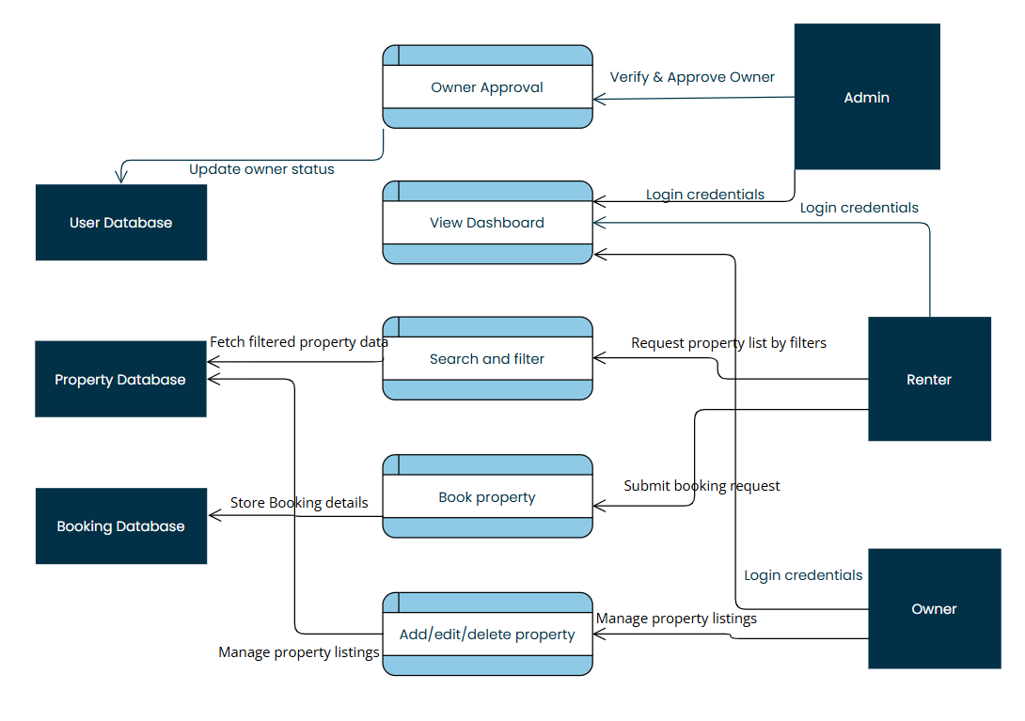

**USER STORIES –HOUSEHUNT**

|  |  |  |  |  |  |  |
| --- | --- | --- | --- | --- | --- | --- |
| **User Type** | **Functional Requirement (Epic)** | **User Story Number** | **User Story / Task** | **Acceptance Criteria** | **Priority** | **Release** |
| **Customer**  **(Mobile User)** | Registration | USN-1 | As a user, I can register for the application by entering my email, password, and confirming my password. | I can access my account/dashboard after registering | High | Sprint- 1 |
|  |  | USN-2 | As a user, I will receive a confirmation email once I have registered. | I can receive a confirmation email and verify my account | High | Sprint- 1 |
|  |  | USN-3 | As a user, I can register using Facebook login. | I can register and access the dashboard using Facebook | Low | Sprint- 2 |
|  |  | USN-4 | As a user, I can register using my Gmail account. | I can sign up and reach the dashboard using Gmail | Medium | Sprint- 1 |
|  | Login | USN-5 | As a user, I can log in using my registered email and password. | I can successfully log in and view my dashboard | High | Sprint- 1 |
|  | Book Property | USN-6 | As a mobile user, I want to book a property directly from my phone | Booking form submits successfully and shows confirmation | High | Sprint- 2 |
| **Customer (Web user)** | Registration/Login | USN-7 | As a web user, I can register and log in through the web portal. | Account is created and dashboard is accessible | High | Sprint- 1 |
|  | Search & Filter | USN-8 | As a web user, I want to filter property listings by location and type | Filters apply and return matching properties | High | Sprint- 2 |
|  | View Booking History | USN-9 | As a web user, I want to view my previous bookings in dashboard | Booking history is shown in user dashboard | Medium | Sprint-2 |
| **Customer Care Executive** | Respond to Support Queries | USN-10 | As a customer care executive,I wa t to view user queries and respond via email | Executive can access a dashboard and reply to users | Low | Sprint -3 |
| **Administrator** | Owner Approval | USN-11 | As an admin, I want to approve or reject owner registration requests | Admin dashboard lists pending requests and updates status | Medium | Sprint-2 |
|  | Manage Bookings | USN-12 | As an admin, I want to monitor and manage all property bookings | All booking records are visible with owner/user links | Medium | Sprint-3 |
|  | Dashboard Overview | USN-13 | As an admin, I want to view summary statistics of users, properties, bookings | Graph or table showing overall platform activity | Low | Sprint-3 |